Project Design Phase-I Solution Architecture

|  |  |
| --- | --- |
| Date | 30 September 2022 |
| Team ID | PNT2022TMID15129 |
| Project Name | SmartFarmer – IoT Enabled Smart Farming Application |
| Maximum Marks | 4 Marks |

**Solution Architecture:**

* The different soil parameters (temperature, humidity, Soil Moisture) are sensed using different sensors, and the obtained value is stored in the IBM cloud.
* Arduino UNO is a microcontroller which used to processes the data obtained from sensors and weather data from weather API.
* Node-red is used as a programming tool to wire the hardware, software, and APIs. The MQTT protocol is followed for communication.
* All the collected data are provided to the user through a mobile application that was developed using the MIT app inventor. The user could make a decision through an app, whether to water the crop or not depending upon the sensor values. By using the app they can remotely operate the motor switch.

**Solution Architecture Diagram:**

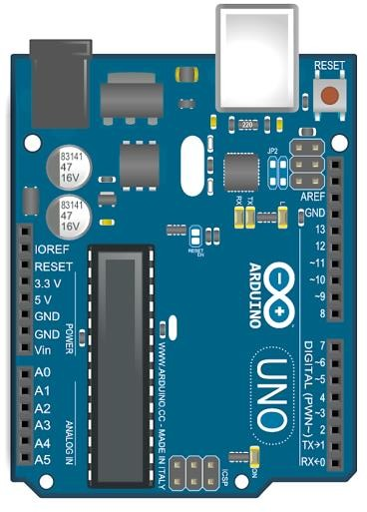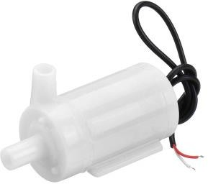



Cloud

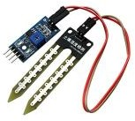

Soil Moisture Sensor

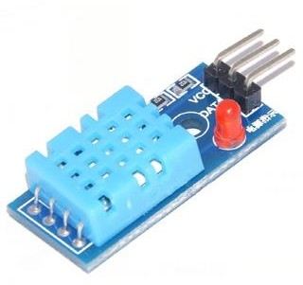

DHT11 Sensor



User



Motor

Open

Weather Api

Node Red

Application